RESOURCE ACQUISITION REPORT
Project Title:
High Availability Router using HSRP and GNS3.
Course:
Computer Networks Lab
Submitted To:
Sir Muhammad Fahad Irshad
Submitted By: (Group 6)
- Sumaiya Bibi F2024266340
- Rameen Junaid F2024266341
- Tayyba Shahzad F2024266348
- Eshmal Zahid F2024266755
Introduction:
This report contains the resources, software tools, and platforms acquired for the implementation of the High Availability Router project using HSRP in GNS3.
Screenshots:
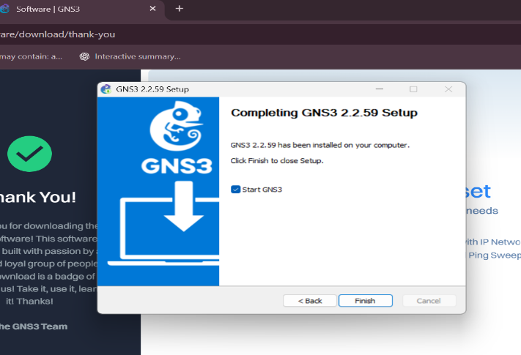
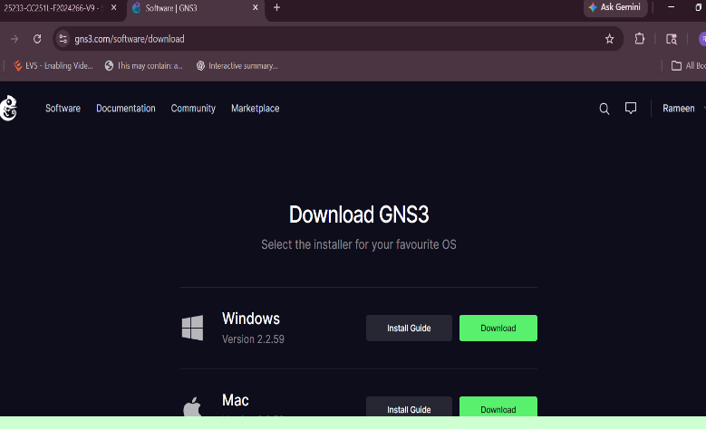

GNS3 website accessed for downloading
GNS3 download process initiated successfully.
the network simulation platform.

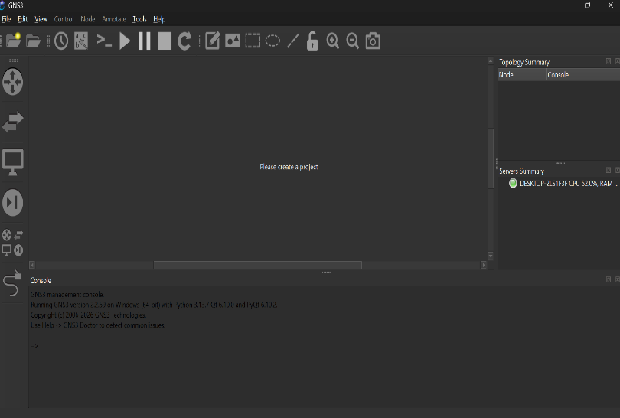
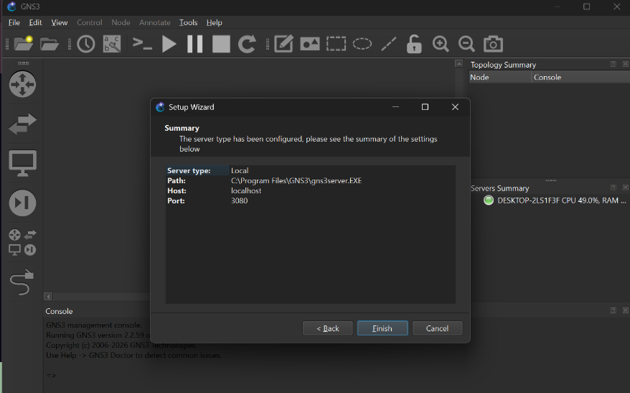

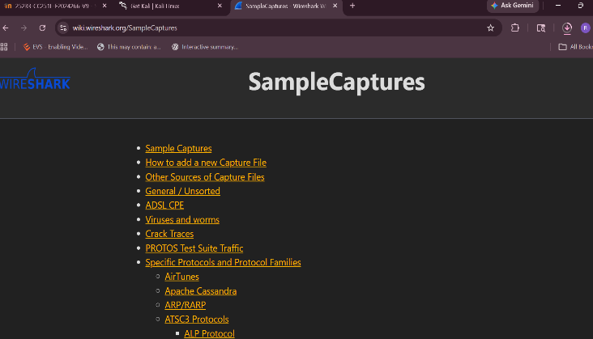
GNS3 installed successfully for network simulation.
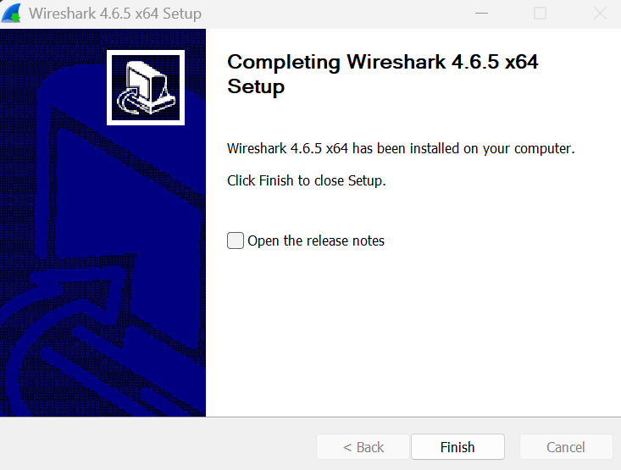

Wireshark official website accessed for
Wireshark installed successfully for packet capturing and troubleshooting.
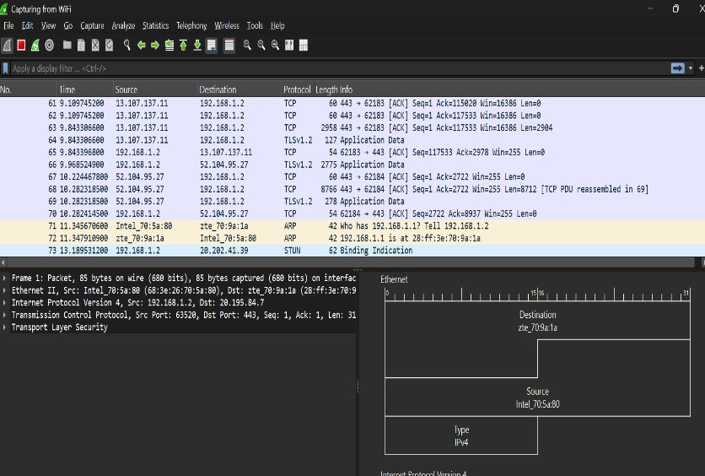
packet analysis tool download.

Wireshark installer downloaded successfully.

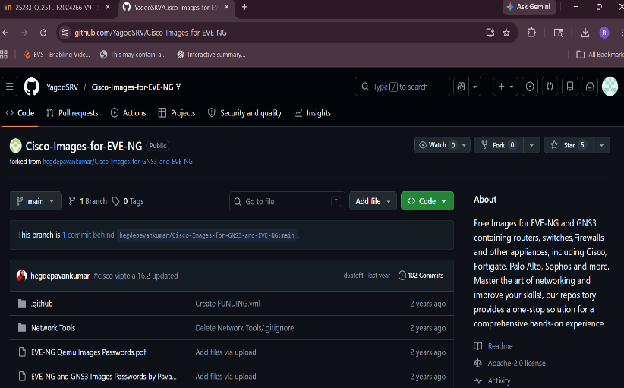

Cisco IOS image repository identified for router
emulation in GNS3.Cisco IOS router image
downloaded successfully
Member Name | GitHub ID
Tayyba Shahzad | tayybashahzad
Sumaiya Bibi | Sumaiya-code-s
Rameen Junaid | Rameen1630
Eshmal Zahid | CodeByEZ
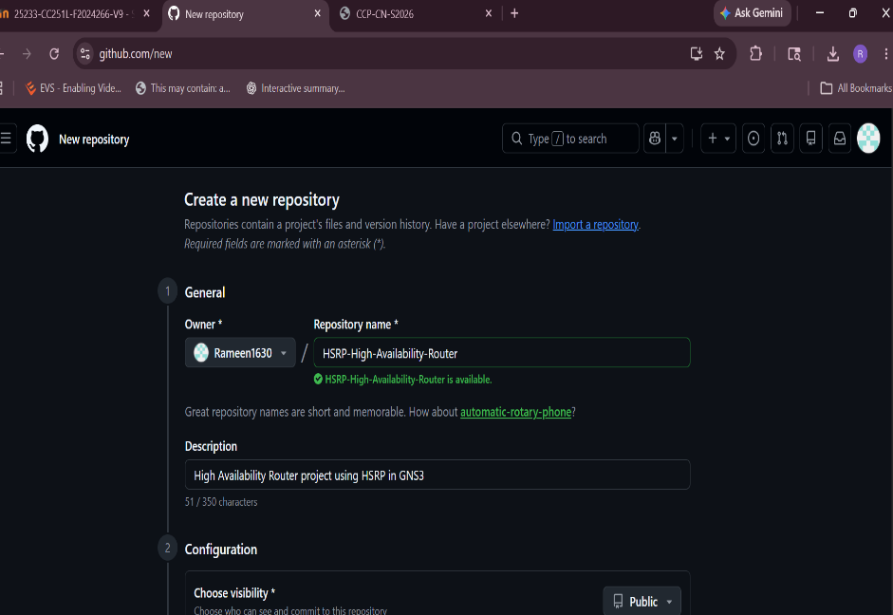
GitHub team Members:

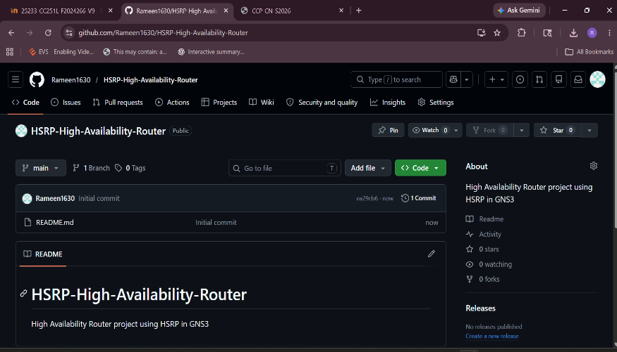

GitHub repository created for team
Collaboration and project management.

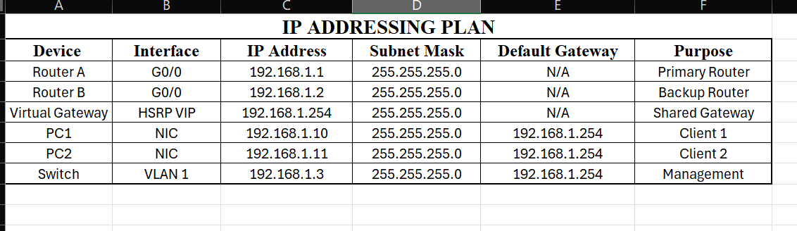

IP addressing plan prepared for network devices
and clients.
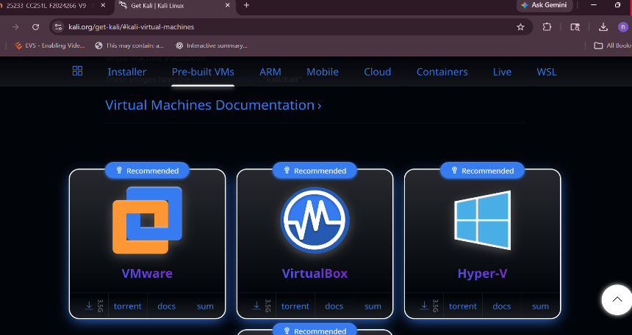

Kali Linux identified for SSH verification and security testing tasks.
Conclusion:
All required software tools, repositories, and project resources were successfully acquired and prepared for the implementation of the High Availability Router project.

